Get t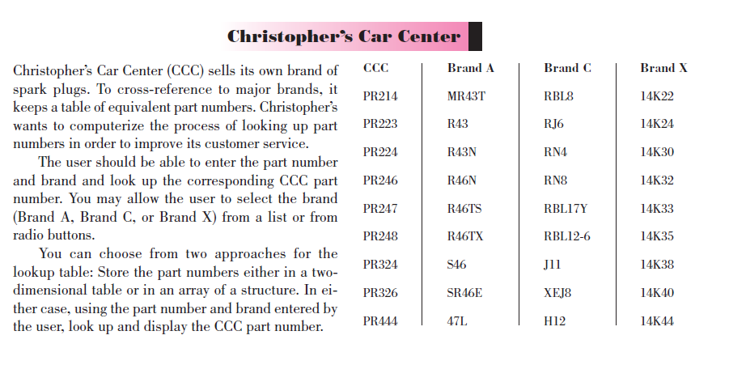

Get the info from a text file by using a loop, use split technique, or loop every 9

Put it into 4 different arrays, for cc, brand a, b, c

Use the lab w/ arrays, the lab 8, loop to match & get ccc

Try getting entire file into an array, then loop like this

First [] (I = 0, I<end, i=+4)

second [] (I =1, I<end, i=+4)

or trying using a number for end, i.e. 36

**CISP 41 -- Project 4 (Christopher’s Car Center)**

**Due Thursday, 11/15/2012**

(Can submit by 12 am on Thursday, 11/22/12, without penalty)

We will practice more with arrays and file for this project.

Perform the “Christopher’s Car Center” case study on page 367 of your textbook.  Feel free to design your own user interface, but it should be reasonable and easy to use.

Some helpful notes:

1.      Load the spark plugs data from a text file.  You can design the format for your input data.  It can be one item per line

            PR214  
            MR43T  
            RBL8  
            14K12  
            PR223  
            …

           or 4 items per line like the table in the text.

            PR214             MR43T            RBL8              14K12  
            PR223             R43                 RJ6                  14K24  
            …

•         Use a table look up similar to the example in chapter 8

•         You can use a two-dimensional table but it is recommended to use an array of structure

•         User must enter the part number for a particular brand using a text box

**Extra credit:** You can earn up to 4 addition points if you implement the following option:

•         Generate a text report (a text file) of all successful searches by brand upon closing the program.  For example:

Brand A  
MR43T                  2  
S46                        1

Brand C  
RJ6                        1  
RN4                      1

Brand X  
14K24                   1

Please provide documentation as specified in project documentation file and applying good coding style because it is part of the grade.  Do not forget to use the provided template.  You must come up with a sufficient number of test cases since the test cases are also part of the grade.  Please submit the following items **in a folder**(or upload via Moodlerooms one .zip file that contains one single pdf file for all the printouts and **all project files**):

1. Project evaluation sheet.
2. Project specification.
3. Status of your program; also indicate if extra credit feature is included.
4. A planning sketch for the form, property settings, and pseudocode.
5. List of test cases and captured screens.
6. Source code.
7. A copy of your project on a USB drive or CD – **all project files** for this program.

If I cannot run your program, points will be deducted so make sure to submit all project files.  Your program will be graded as follow:

* Correctness: 26 points
* Test Cases:  4 points
* Documentation/Coding Style:  10 points

© by T. Vo Last updated on 10/31/2012 23:16:05

column 1: PR214,PR223,PR224,PR246,PR247,PR248,PR324,PR326,PR444  
Brands:  
column 2: MR43T,R43,R43N,R46N,R46TS,R46TX,S46,SR46E,47L  
column 3: RBL8,RJ6,RN4,RN8,RBL17Y,RBL12-6,J11,XEJ8,H12  
column 4L 14K22,14K24,14K30,14K32,14K33,14K35,14K38,14K40,14K44

column 1: “,”PR214”,”PR223”,”PR224”,”PR246”,”PR247”,”PR248”,”PR324”,”PR326”,”PR444”  
Brands:   
column 2: “,”MR43T”,”R43”,”R43N”,”R46N”,”R46TS”,”R46TX”,”S46”,”SR46E”,”47L”  
column 3: “,”RBL8”,”RJ6”,”RN4”,”RN8”,”RBL17Y”,”RBL12-6”,”J11”,”XEJ8”,”H12”  
column 4L “,”14K22”,”14K24”,”14K30”,”14K32”,”14K33”,”14K35”,”14K38”,”14K40”,”14K44”

for (int indexInteger = 2; indexInteger <= 100; indexInteger += 2)

// Continue a for loop.

for (int loopInteger = 0; loopInteger <= nameListBox.Items.Count – 1;   
 loopInteger++)

{

if (nameListBox.Items[loopInteger].ToString() == string.Empty)

{

continue;

}

// Code to do something with the name found.

Console.WriteLine("Name = " + nameListBox.Items[loopInteger].ToString());

}

